CONTACT:
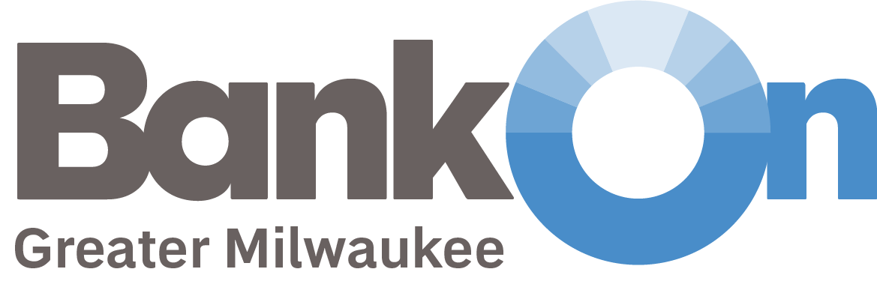
Jessica Wetzel
Communications & Membership Director
Urban Economic Development Association of WI
jessica@uedawi.org | 608.358.1655

FOR IMMEDIATE RELEASE

Bank On certified accounts offer a safe and affordable place for Milwaukee-area residents to deposit stimulus checks, unemployment income, tax refunds.

MILWAUKEE, WI – As the number of people filing for unemployment compensation rises and a federal stimulus package that includes direct payments to tax payers nears passage, it is important that individuals and families have somewhere safe to deposit and access these funds. Bank On Greater Milwaukee is encouraging Milwaukee-area residents to open a Bank On certified account where holders can access mobile banking, direct deposit, bill pay, ATM’s and more through area banks and credit unions they are already familiar with.

Over 40,000 households in Milwaukee are unbanked, meaning no one in the home owns a traditional deposit or savings account where monthly payroll and other timely income, like unemployment, stimulus payments, and tax refunds can be securely deposited. Bank On accounts allow holders to easily use and move their money around while the state’s “safer at home” order temporary limits in-person branch access. However, these accounts will continue to save people time and money far after COVID-19 is under control.

“Many are in need of funds right away – those without bank accounts will find themselves waiting for a check in the mail and visiting costly check-cashing services where they’ll be required to pay fees at a time when they’re not sure if and when more income will be received,” says Constance Alberts, Bank On Greater Milwaukee Program Manager.

Bank On accounts are safe, affordable and functional. Specifically, these accounts do not allow overdraft or non-sufficient funds fees, so holders will never be hit with a surprise fee. They also charge $5 or less per month and do not charge for mobile banking, deposits, withdrawals, or bill payments. The process of opening an account varies by financial institution, (particularly during this time of social distancing) but in general accounts can be opened online, in-person, over the phone or via a mobile app. A full list of certified accounts and how to open them can be found on the Bank On Greater Milwaukee website.

About Bank On Greater Milwaukee Coalition
Bank On Greater Milwaukee is a coalition of community-based organizations, financial institutions and local government agencies that provide services and resources such as financial education, credit counseling, savings programs, banking series, credit repair, employment assistance, youth engagement and other financial empowerment programming. Coalition members work to connect all Milwaukee residents to safe and appropriate financial products and services.

Bank On Greater Milwaukee is part of the national Bank On movement that is made up similar local coalitions across the country. The Urban Economic Development Association of Wisconsin UEDA serves as the convening agency for Bank On Greater Milwaukee.

###

